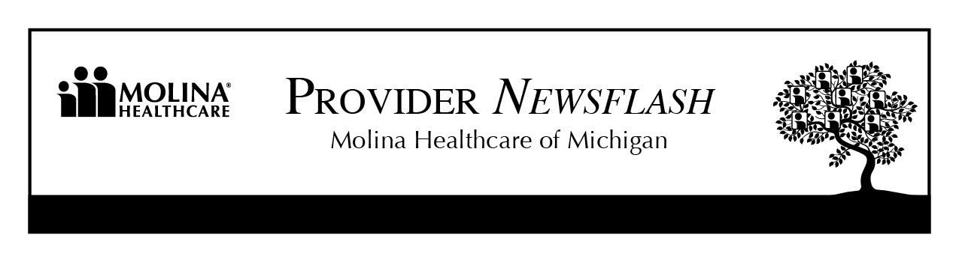

January 21, 2014

Molina Healthcare of Michigan Remittance Advice – Correction

Starting at the end of December 2013, RA’s and 837 files were sent out with incorrect Remark Codes.

Contractual/Adjustments should have been reporting as a CO-45, however, the RA’s are reporting them as CO-16 (denials) and CO-96 (non- covered charges). This is leaving incorrect balances to the patient responsibility.

This has been identified and corrected as of Friday, January 10, 2014. Replacement file(s) and remits, via secured e-mail, can be requested by sending an email to: EDI.Eraeft@MolinaHealthCare.Com.

